**ESP8266 AP mode changes**

**Written By Bill Lu**

Changes has been applied to WiFiManager.cpp and WiFiManager.h so make sure you have updated your Arduino library.

I’m going to explain changes I made to the WiFiManager.cpp and WiFiManager.h.

Let’s starts with WiFiManager.h.

On line 28, you will see a const char named HTTP_PORTAL_OPTIONS.



HTTP_PORTAL_OPTIONS is the HTML code of main page. Actually, it is just the option part of the page so it is made by different “button”.

The main page is actually separated into different parts and program has to put different parts together to assembly a web page. Below is other parts of the web page.

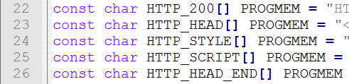

After that are codes I used to make web page for different input.

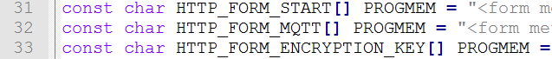

HTTP_FORM_MQTT represents the input fields written in HTML. Those fields are used to accept user’s MQTT information. HTTP_FORM_ENCRYPTION_KEY is a form to accept user’s encryption key.

After that we have different parts of web page.

HTTP_END is ending part of the page. HTTP_SCAN_LINK is an action which direct user to WiFi scan page.

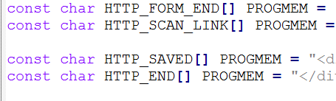

After that, I made some public variables so we can access them in our main program.

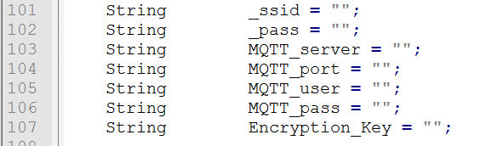

Those variables are all string which means I convert user’s input to string.

I then create serval functions to handle the user action.

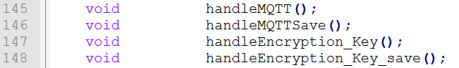

Now let’s move to WiFiManager.cpp to see how functions work.

handleMQTT() is the function which get called when user click “MQTT Server Setting”. It sends the HTTP_FORM_MQTT (Highlighted part below) to front end so user can input MQTT information.

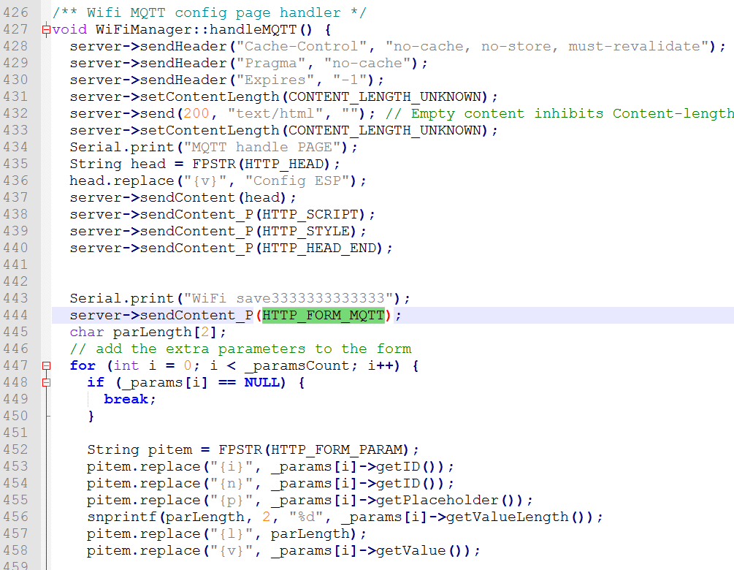

When user click “save” button, handleMQTTSave() function was called.

handleMQTTSave() was called because I modified the flowing parts.

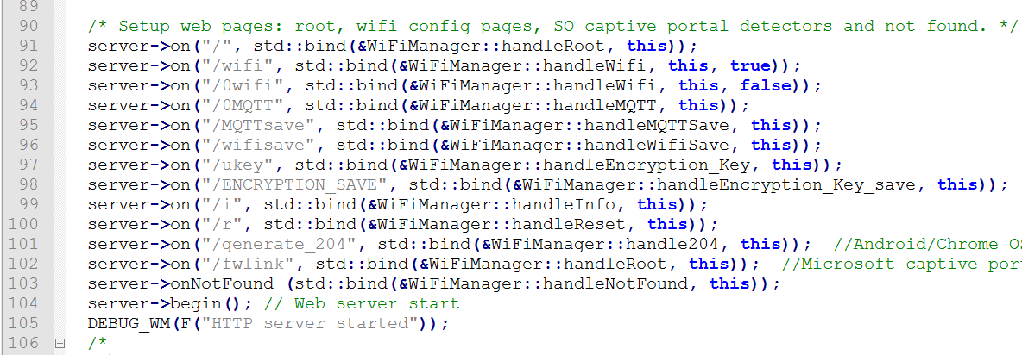

As we can see, string after the on is the command for different operations.

When user click different buttons in our web page, those button will send a special button code back to our code handler so we can know when button user has clicked. Then, main program will call different functions according to user’s input. In order to make my functions work, I add codes from line 94-98.

handleMQTTSave() is called, it gets user input and assign those values to our public variables so our main function can access. Each field in form we send is assigned by a special value. handleMQTTSave() will know what values it gets according to the special code.

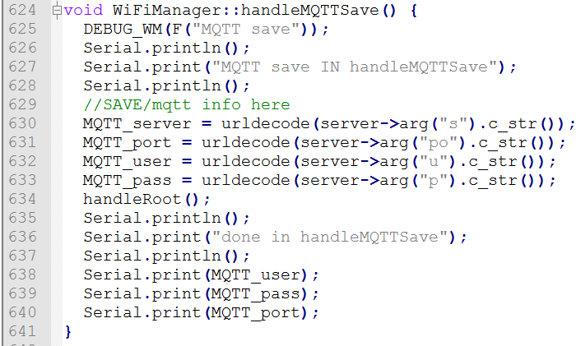

Same ideas applied to handleEncryption_Key() and handleEncryption_Key_save().